 

**SRI SIDDHARTHA INSTITUTE OF TECHNOLOGY**

**(A Constituent college of Sri Siddhartha Academy of Higher Education)**

**Department of Computer Science & Engineering**

**Report on “DBMS Lab Programs” & Mini Project on “Student Management System”**

***Submitted by***

**Srinidhi B (17CS104)**

**Rohan T S (17CS084)**

**Sachin A R Bhat(17CS087)**

**Sathwik R Jain(17CS093)**

**UNDER THE GUIDANCE OF:**

**Sahana Dr.S. Kumaraswamy Ph.D.,**

Assistant Professor Professor

Dept. of C.S.E . Dept. of C.S.E.

S.S.I.T,Tumkur S.S.I.T,Tumkur

***Certificate***

This is to certify that the course ***DBMS Lab Programs with mini project “Student Management System” (CS5L02)*** has been completed successfully in fifth semester of Bachelor of Engineering in Computer Science and Engineering of Sri Siddhartha Academy of Higher Education during the academic year 2019-20.

**UNDER THE GUIDANCE OF:**

**Sahana Dr.S. Kumaraswamy Ph.D.,**

Assistant Professor Professor

Dept. of C.S.E . Dept. of C.S.E.

S.S.I.T,Tumkur S.S.I.T,Tumkur

**Dr.M.Siddappa Ph.D.**

Professor & Head,

Dept. of C.S.E.

S.S.I.T., Tumkur

Examiner 1 Name: Examiner 2 Name:

Signature: Signature:

**Table of Contents**

MINI PROJECT “STUDENT MANAGEMENT SYSTEM”

1. Introduction

1.1 Purpose of the Project

1.2 Scope of the Project

1.3 Definitions, Acronyms and Abbreviations

1. Requirement Specifications

2.1 System requirements

2.1.1 Hardware Configuration

2.1.2 Software Configuration

2.2 Development Environment

1. System Design

3.1 Relationship Diagram

3.2 E R Diagram

1. Sample Output

Screenshots

1. Conclusion

**MINI PROJECT ON**

**‘’ STUDENT MANAGEMENT SYSTEM”**

**CHAPTER 1**

**INTRODUCTION:**

**1.1 Purpose:**

The objective of Student information System is to allow the administrator of any organization to edit and find out the personal details of a student and allows the student to keep up to date his profile .It’ll also facilitate keeping all the records of students, such as their id, name, mailing address, phone number, DOB etc. So all the information about an student will be available in a few seconds. Overall, it’ll make Student Information Management an easier job for the administrator and the student of any organization. The main purpose of this SRS document is to illustrate the requirements of the project Student information System and is intended to help any organization to maintain and manage its student’s personal data.

**1.2 Scope :**

Without a Student information System, managing and maintaining the details of the student is a tedious job for any organization. Student Information system will store all the details of the students including their background information, educational qualifications, personal details and all the information related to their resume . Login module: Login module will help in authentication of user accounts .Users who have valid login id and password can only login into their respective accounts.

**Search module:**

Suppose there are hundreds of students and from this we have to search a particular student and we know the name of the student .In manual system it is a tedious task though we know the name of the student, but using this module we can easily search the student by specifying the name of the student in the search criteria. Thus this module will help the administrator in searching the student with various criteria easily.

**Registration Module and Account Management:**

This module will help the student get registered from anywhere if internet is present .This module will really simplify the task of on paper registration. Also after successful registration the user can update information and change their password as and when required.

**User Management:**

This module will help the administrator in enabling/disabling a user account and updating user information as required. Purpose of project is to maintain details of the students such as storing information about:

♣ Student id

♣ Student password

♣ Student name

♣ Student DOB

♣ Student mailing address

♣ Gender

♣ Registration date

♣ Student status

♣ Contact no

♣ Qualification

♣ City

♣ Resume

♣ Image

**1.3 Definitions, Acronyms and Abbreviations :**

**♣ Personal details**:

Details of student such as user id, phone number, address, image, resume, e-mail address etc.

• **Contact details:**

Details of contact associated with the student.

**• SRS**: System requirement Specification

**• WWW**: World Wide Web

**CHAPTER 2**

**REQUIREMENTS SPECIFICATIONS**

**2.1 System Requirements**

**2.1.1 Software configuration:**

A major element in building a system is the section of compatible software since the software in the market is experiencing in geometric progression. Selected software should be acceptable by the firm and one user as well as it should be feasible for the system. This document gives a detailed description of the software requirement specification. The study of requirement specification is focused specially on the functioning of the system. It allow the developer or analyst to understand the system, function to be carried out the performance level to be obtained and corresponding interfaces to be established.

Front end tool: VISUAL BASICS 6.0

Back end tool:MS ACCESS

Operating system: Windows 10

**2.1.2 Hardware configuration:**

The section of hardware configuration is an important task related to the software development insufficient random access memory may affect adversely on the speed and efficiency of the entire system. The process should be powerful to handle the entire operations. The hard disk should have sufficient capacity to store the file and application.

Processor: Intel core i3

Processor speed: 2.30 GHz

System memory: 500GB

RAM: 2 GB

**2.2 Development Environment**

|  |  |
| --- | --- |
| **Visual Basic** | |
|  | |
| Visual Basic 6.0 IDE on [Windows XP](https://en.wikipedia.org/wiki/Windows_XP) | |
| [**Paradigm**](https://en.wikipedia.org/wiki/Programming_paradigm) | [Object-based](https://en.wikipedia.org/wiki/Object-based) and [Event-driven](https://en.wikipedia.org/wiki/Event-driven_programming) |
| [**Developer**](https://en.wikipedia.org/wiki/Software_developer) | [Microsoft](https://en.wikipedia.org/wiki/Microsoft) |
| **First appeared** | 1991; 28 years ago |
|  | |
| [**Stable release**](https://en.wikipedia.org/wiki/Software_release_life_cycle) | 6.0 / 1998; 21 years ago |
| [**Typing discipline**](https://en.wikipedia.org/wiki/Type_system) | [Static](https://en.wikipedia.org/wiki/Static_type), [strong](https://en.wikipedia.org/wiki/Strongly-typed_programming_language) |
| [**OS**](https://en.wikipedia.org/wiki/Operating_system) | [Microsoft Windows](https://en.wikipedia.org/wiki/Microsoft_Windows) and [MS-DOS](https://en.wikipedia.org/wiki/MS-DOS) |
| **Website** | [msdn.microsoft.com/en-us/library/windows/desktop/ms788229.aspx](https://msdn.microsoft.com/en-us/library/windows/desktop/ms788229.aspx) |
| **Major**[**implementations**](https://en.wikipedia.org/wiki/Programming_language_implementation) | |
| [Microsoft Visual Studio](https://en.wikipedia.org/wiki/Microsoft_Visual_Studio) | |
| **Influenced by** | |
| [BASIC](https://en.wikipedia.org/wiki/BASIC) | |
| **Influenced** | |
| [Visual Basic .NET](https://en.wikipedia.org/wiki/Visual_Basic_.NET), [Gambas](https://en.wikipedia.org/wiki/Gambas), [Xojo](https://en.wikipedia.org/wiki/Xojo), [Basic4ppc](https://en.wikipedia.org/wiki/Basic4ppc) and [NS Basic](https://en.wikipedia.org/wiki/NS_Basic) | |

**CHAPTER 3**

**SYSTEM DESIGN**

**3.1 Relationship Diagram:**

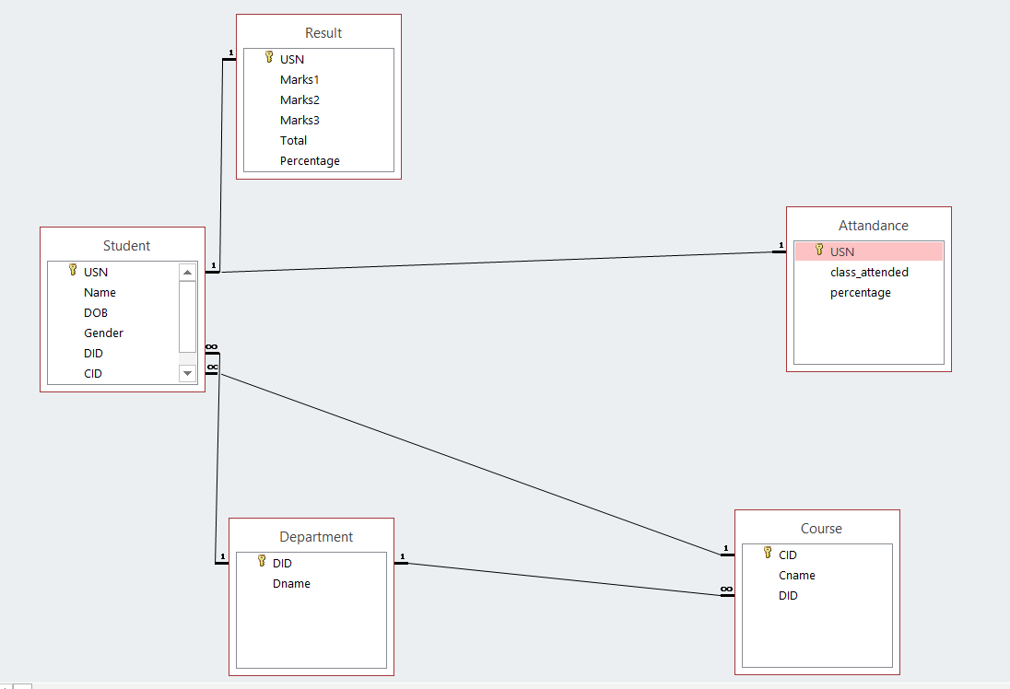**Fig 3.1-Relationship Diagram**

**3.2 E R diagram:**

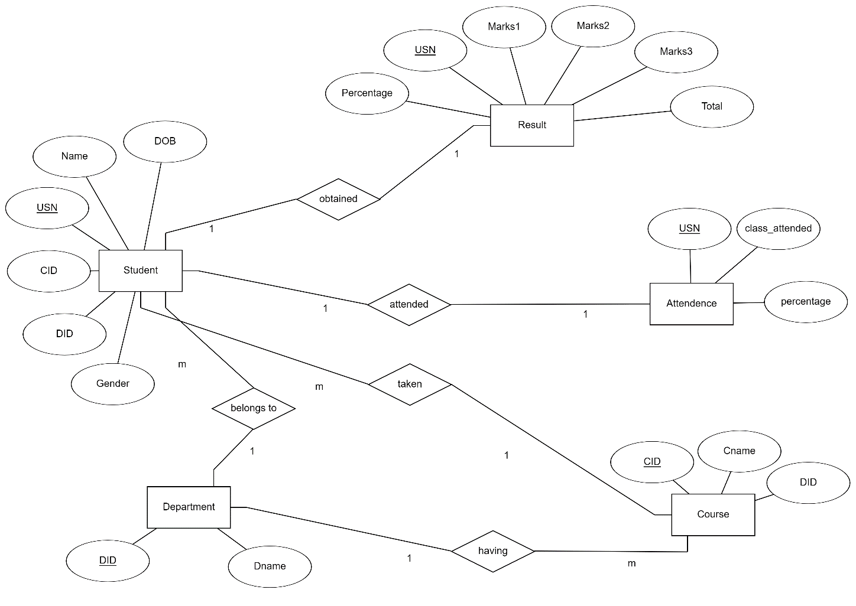

**Fig 3.2-ER Diagram**

**Chapter 4**

**SAMPLE OUTPUT**

**Home Screen:**

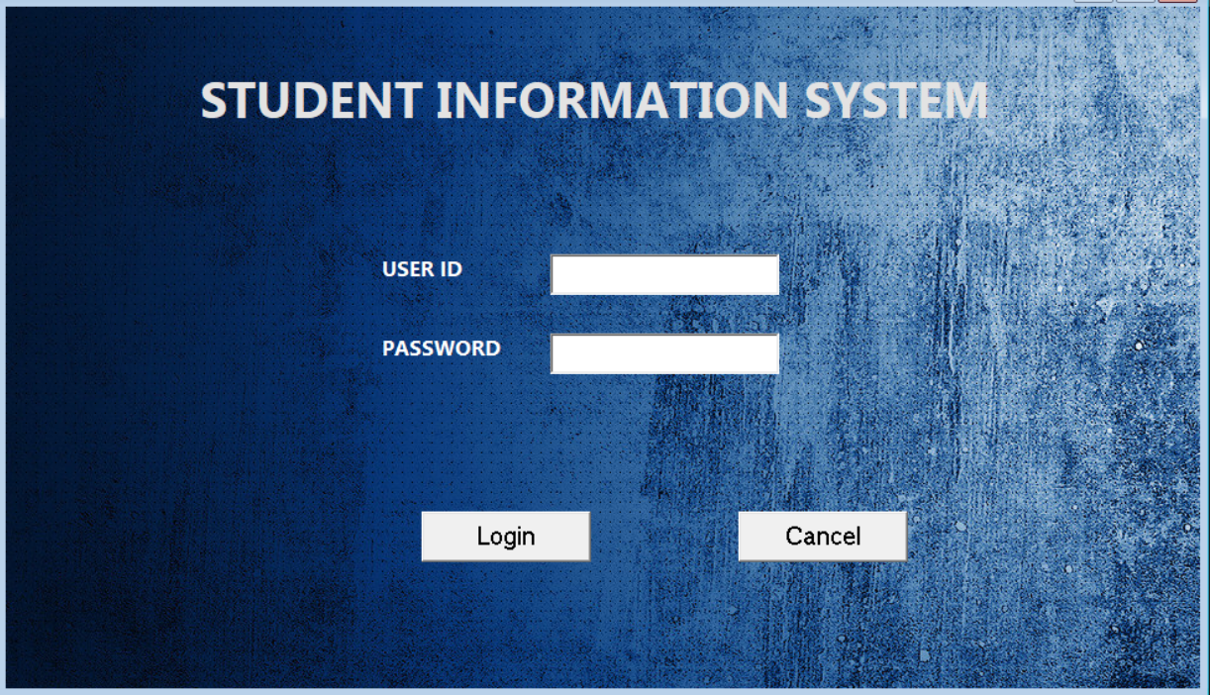

Fig 4.1: Home page.

**Main page**

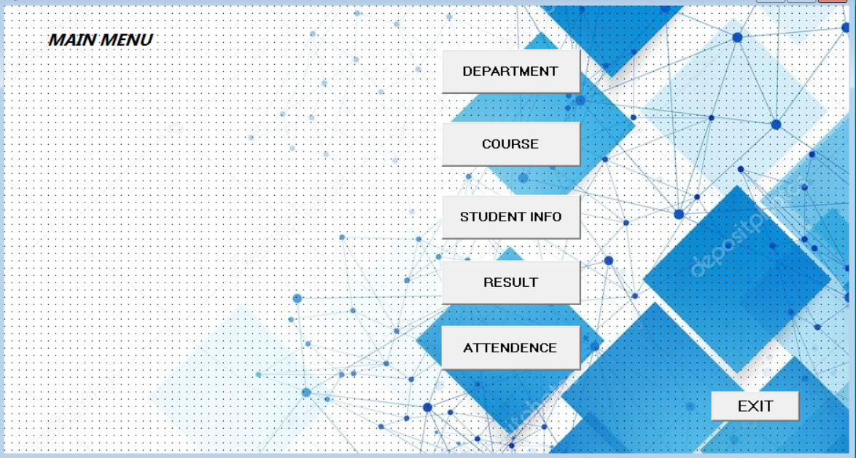**:**Fig 4.2: Main Page information.

.

**Attendence page**

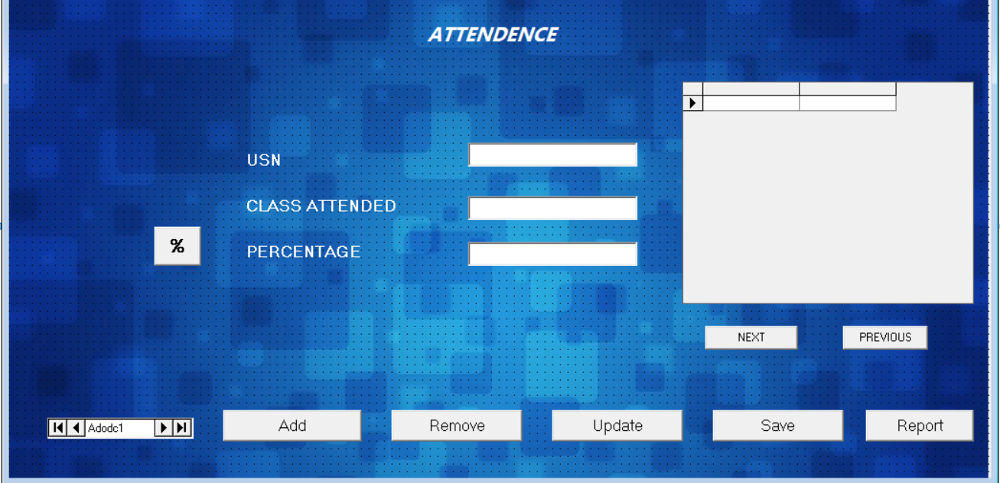

**Student page**

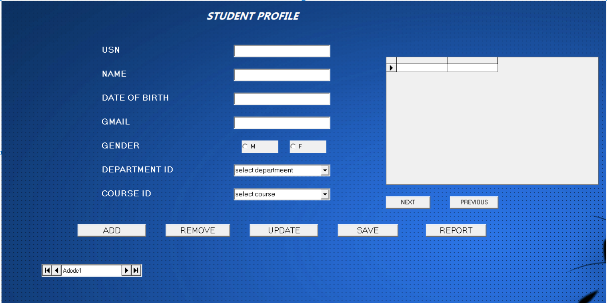

Fig 4.4: Student information page.

**Department Page**

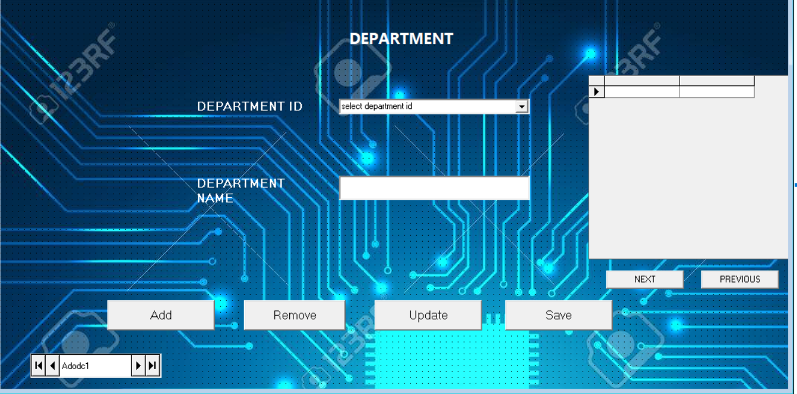

**Course page**

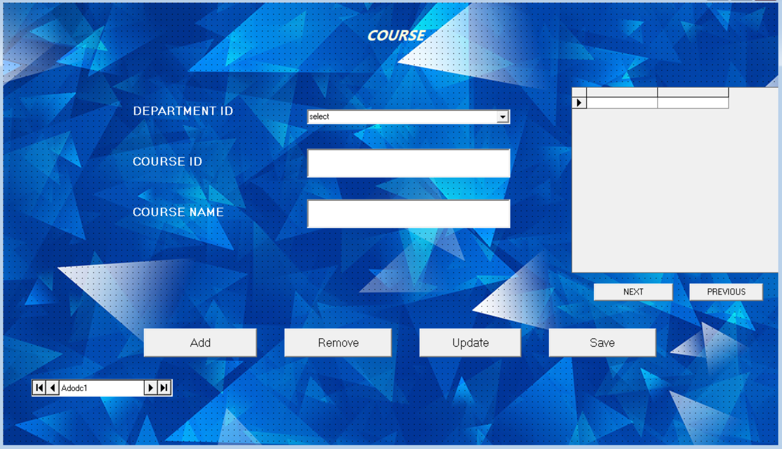

**CHAPTER 5**

**CONCLUSION**

This project is developed using VISUAL BASICS 6.0 and MS-ACCESS which is based on the requirements of the user and the analysis of the existing system, with flexibility for future enhancement.

This project is used for managing the various activities in the School

♣ The Student Information Management System can be enhanced to include some other functionality like marks ,attendance management.

♣ Talent management of students based on their performance evaluation can be added.

♣ Social networking can also be added wherein students can interact with each other

♣ Online class functionality can be added.

♣ Can evolve as an online institution.

♣ Functionality of chat and messages can be added.

♣ Online exam functionality can be added.

♣ Online resume builder functionality can also be added.

**Bibliography:**

* [**www.W3schools.com**](http://www.W3schools.com)
* [**www.stackoverflow.com**](http://www.stackoverflow.com)
* [**www.quara.com**](http://www.quara.com)
* [**www.youtube.com**](http://www.youtube.com)
* [**www.wikipedia.com**](http://www.wikipedia.com)